Lunisolar Calendar
# Source: AI Source: Provided by: [Data Path: Persons Table -> ID Column: 1, Name_En Column: Motasem Essam] -> From: [ChatGPT] on [7/17/2026]
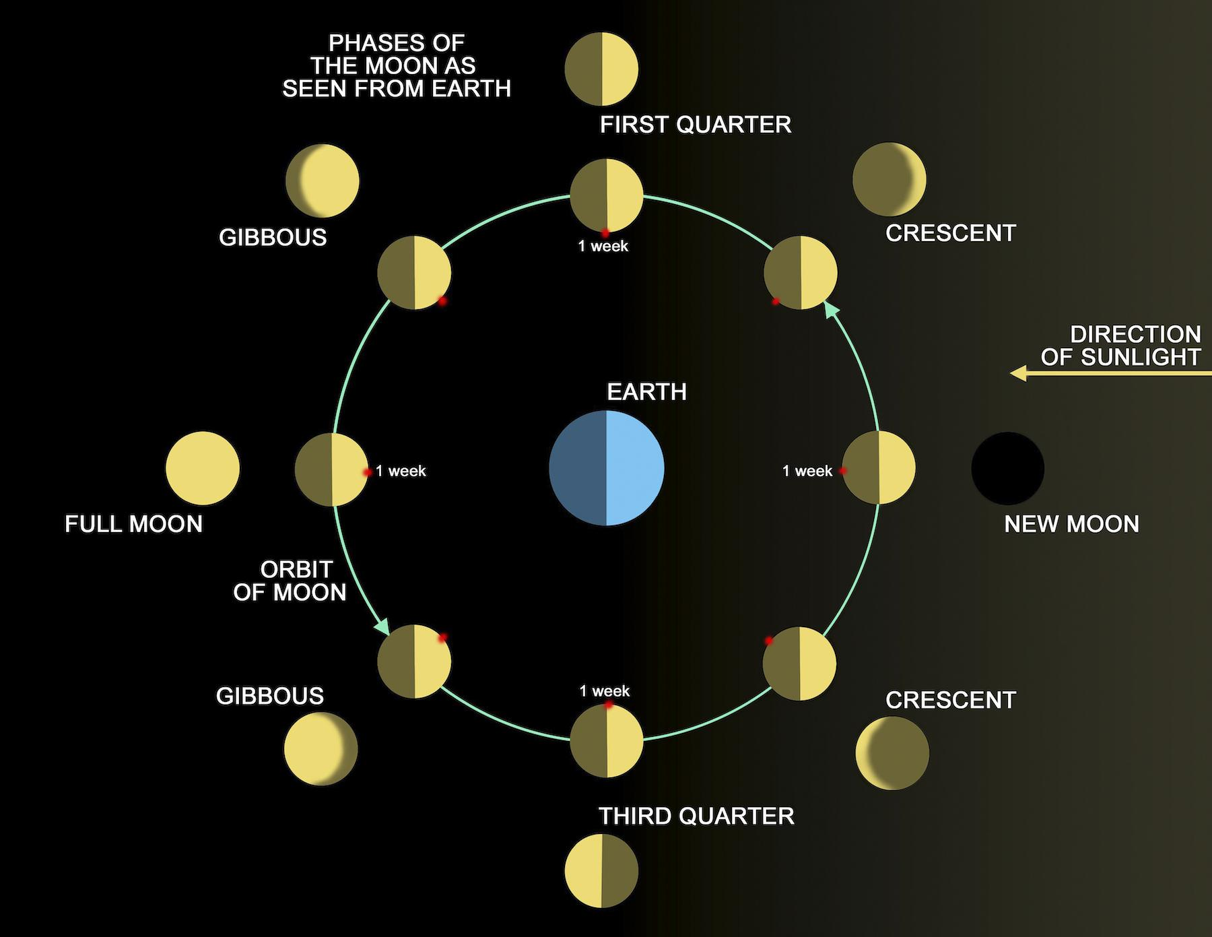
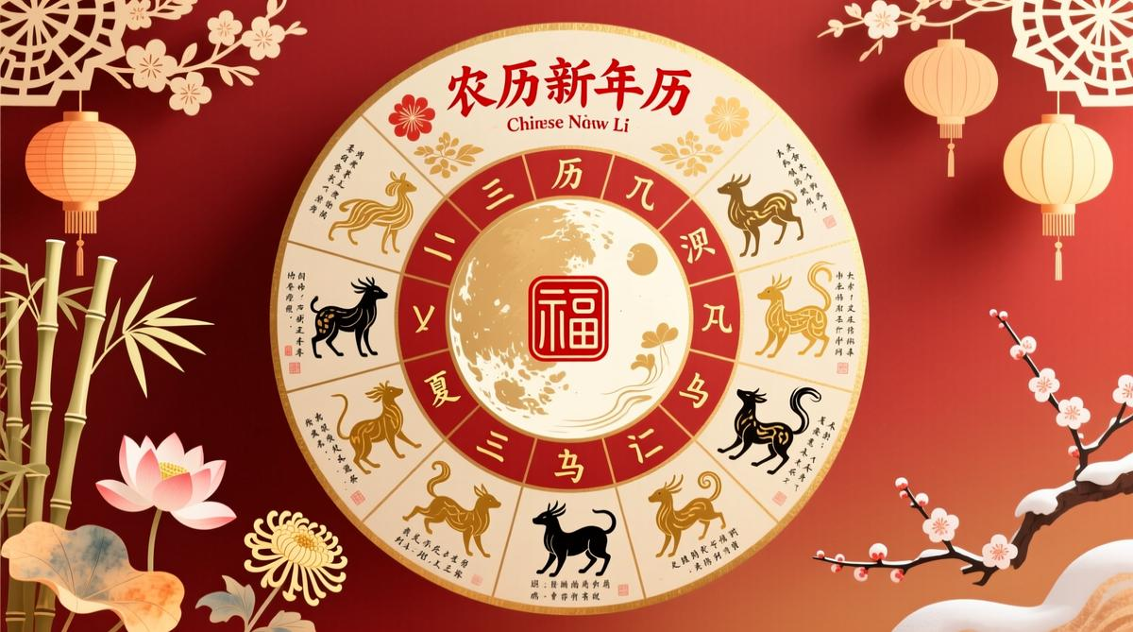
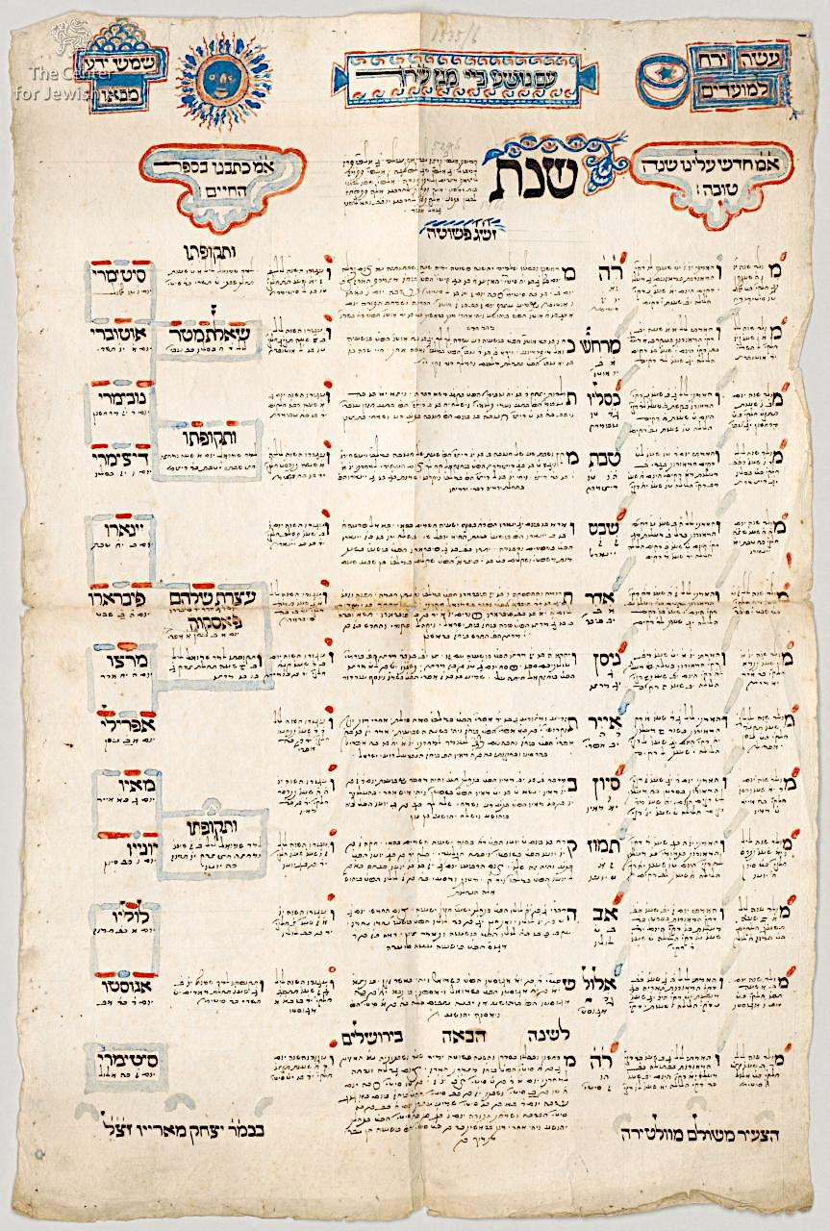
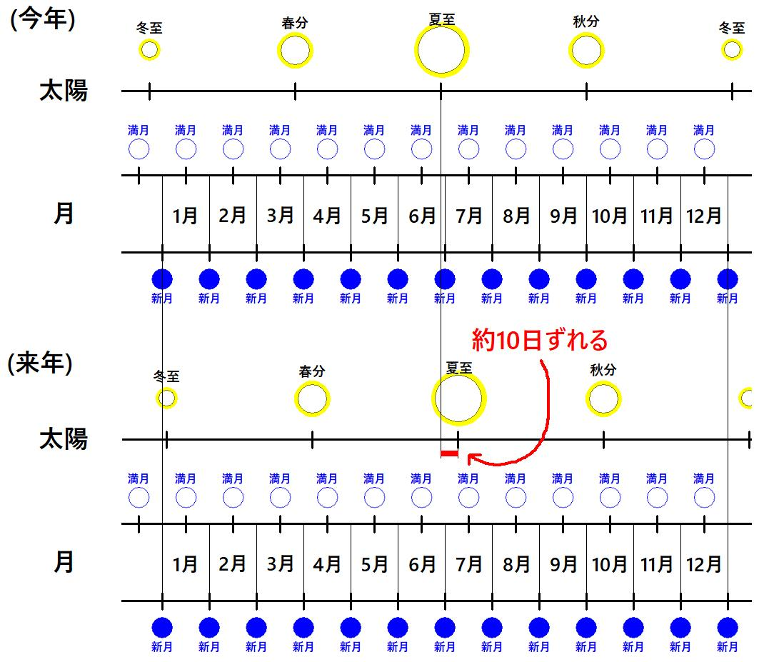
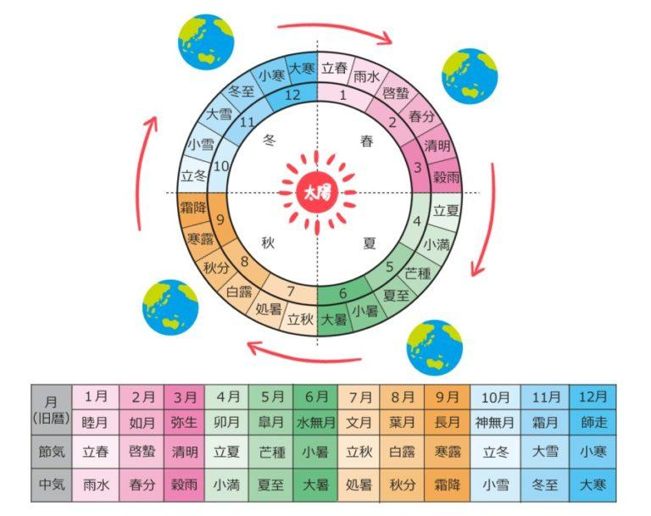
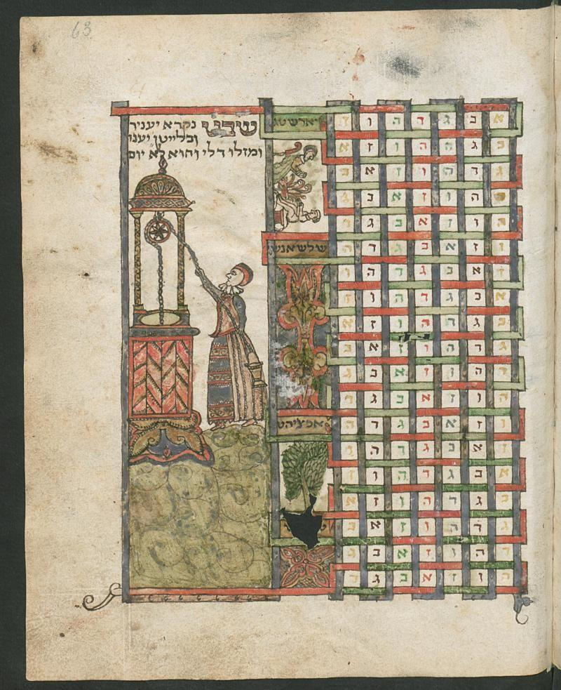
A Lunisolar Calendar is a calendar system that combines the lunar cycle (the phases of the Moon) with the solar year (the Earth's revolution around the Sun). In this system, months follow the Moon, while leap months are added periodically to keep the calendar synchronized with the seasons.
Lunisolar calendars preserve the natural rhythm of lunar months while ensuring that seasonal events, such as harvest festivals or spring celebrations, occur at approximately the same time each solar year.

Definition
# Source: AI Source: Provided by: [Data Path: Persons Table -> ID Column: 1, Name_En Column: Motasem Essam] -> From: [ChatGPT] on [7/17/2026]
A Lunisolar Calendar is a calendar system in which months are based on the Moon's phases, while leap months are periodically added to keep the calendar aligned with the solar year and the seasons.

Purpose
# Source: AI Source: Provided by: [Data Path: Persons Table -> ID Column: 1, Name_En Column: Motasem Essam] -> From: [ChatGPT] on [7/17/2026]
A lunisolar calendar is used to:
- Measure time using lunar months.
- Keep years synchronized with the seasons.
- Determine religious and cultural festivals.
- Support agriculture.
- Preserve traditional observances.

Astronomical Basis
# Source: AI Source: Provided by: [Data Path: Persons Table -> ID Column: 1, Name_En Column: Motasem Essam] -> From: [ChatGPT] on [7/17/2026]
A lunisolar calendar combines two astronomical cycles:
Lunar Cycle
One lunar month averages:
$$29.5306\text{ days}$$
Solar Cycle
One tropical (solar) year averages:
$$365.2422\text{ days}$$
Twelve lunar months total only about:
$$12×29.5306≈354.37\text{ days}$$
This is approximately 11 days shorter than the solar year, so a leap month is occasionally inserted to realign the calendar with the seasons.

Main Characteristics
# Source: AI Source: Provided by: [Data Path: Persons Table -> ID Column: 1, Name_En Column: Motasem Essam] -> From: [ChatGPT] on [7/17/2026]
A lunisolar calendar typically has:
- 12 lunar months in a common year.
- 13 lunar months in a leap year.
- 353–355 days in common years.
- 383–385 days in leap years.
- Seasonal alignment maintained through leap months.

Components
# Source: AI Source: Provided by: [Data Path: Persons Table -> ID Column: 1, Name_En Column: Motasem Essam] -> From: [ChatGPT] on [7/17/2026]
A lunisolar calendar includes:
- Day
- Week
- Lunar month
- Year
- Leap month adjustment

Leap Month
# Source: AI Source: Provided by: [Data Path: Persons Table -> ID Column: 1, Name_En Column: Motasem Essam] -> From: [ChatGPT] on [7/17/2026]
Unlike a solar calendar, which adds an extra day, a lunisolar calendar adds an entire month when needed.
This keeps:
- Lunar months
- Solar seasons
properly synchronized.

Relationship to the Seasons
# Source: AI Source: Provided by: [Data Path: Persons Table -> ID Column: 1, Name_En Column: Motasem Essam] -> From: [ChatGPT] on [7/17/2026]
Because leap months are inserted periodically:
- Spring festivals remain in spring.
- Harvest festivals remain in autumn.
- Religious observances stay close to their traditional seasons.

Examples of Lunisolar Calendars

1. Hebrew Calendar
# Source: AI Source: Provided by: [Data Path: Persons Table -> ID Column: 1, Name_En Column: Motasem Essam] -> From: [ChatGPT] on [7/17/2026]
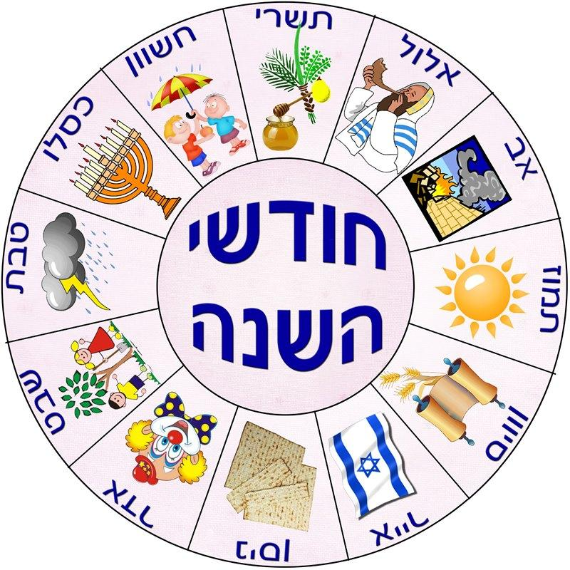
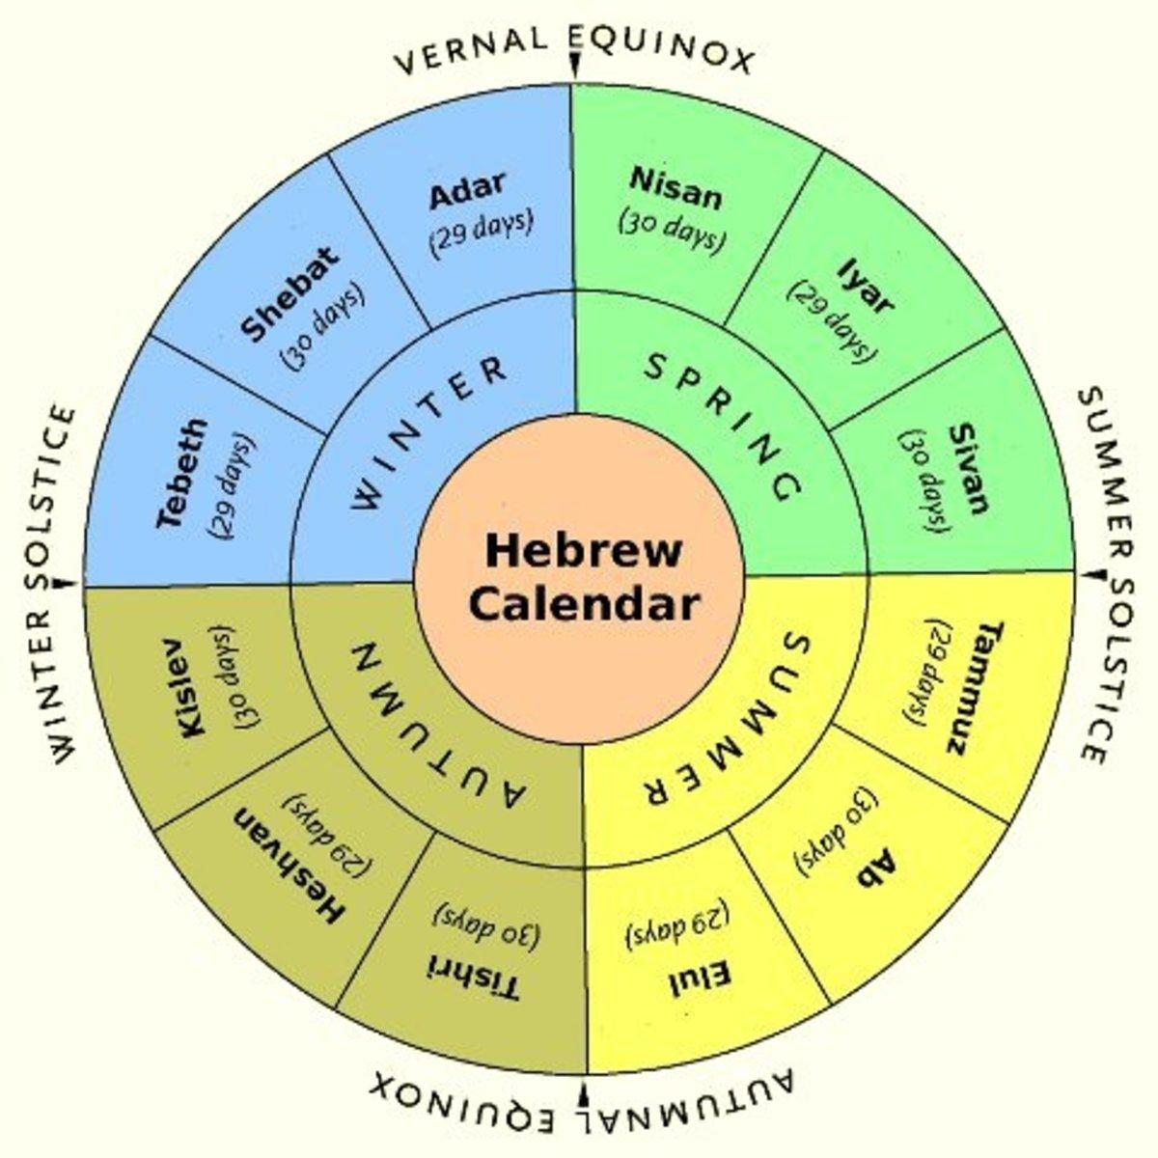
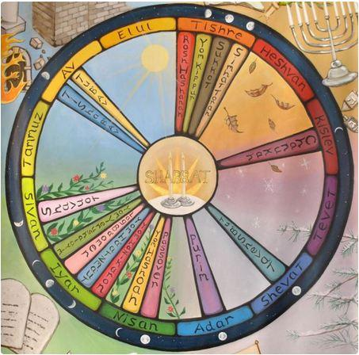
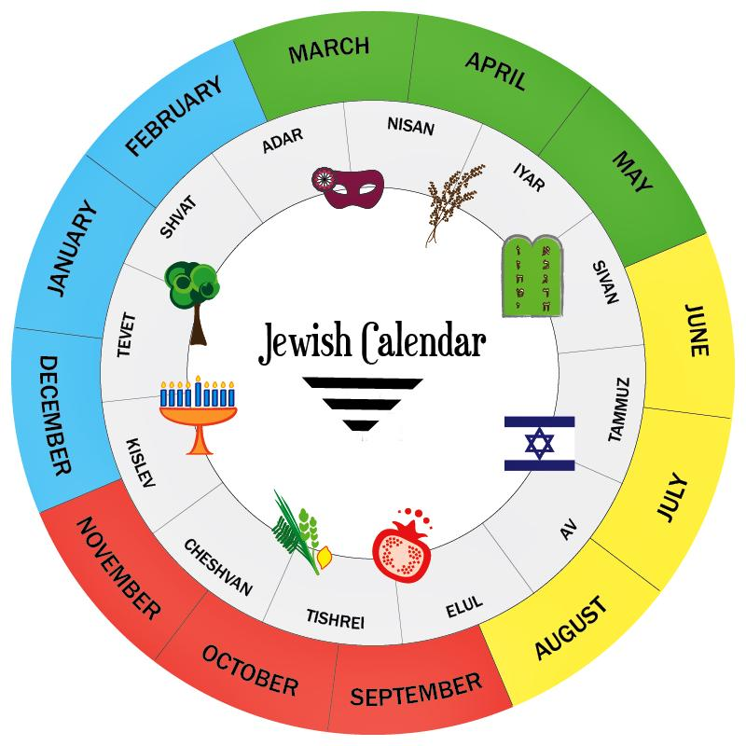
Characteristics
- 12 or 13 months
- Leap month added 7 times in every 19 years
- Used for Jewish religious observances
Major festivals include:
- Passover
- Rosh Hashanah
- Yom Kippur
- Hanukkah

2. Chinese Calendar
# Source: AI Source: Provided by: [Data Path: Persons Table -> ID Column: 1, Name_En Column: Motasem Essam] -> From: [ChatGPT] on [7/17/2026]
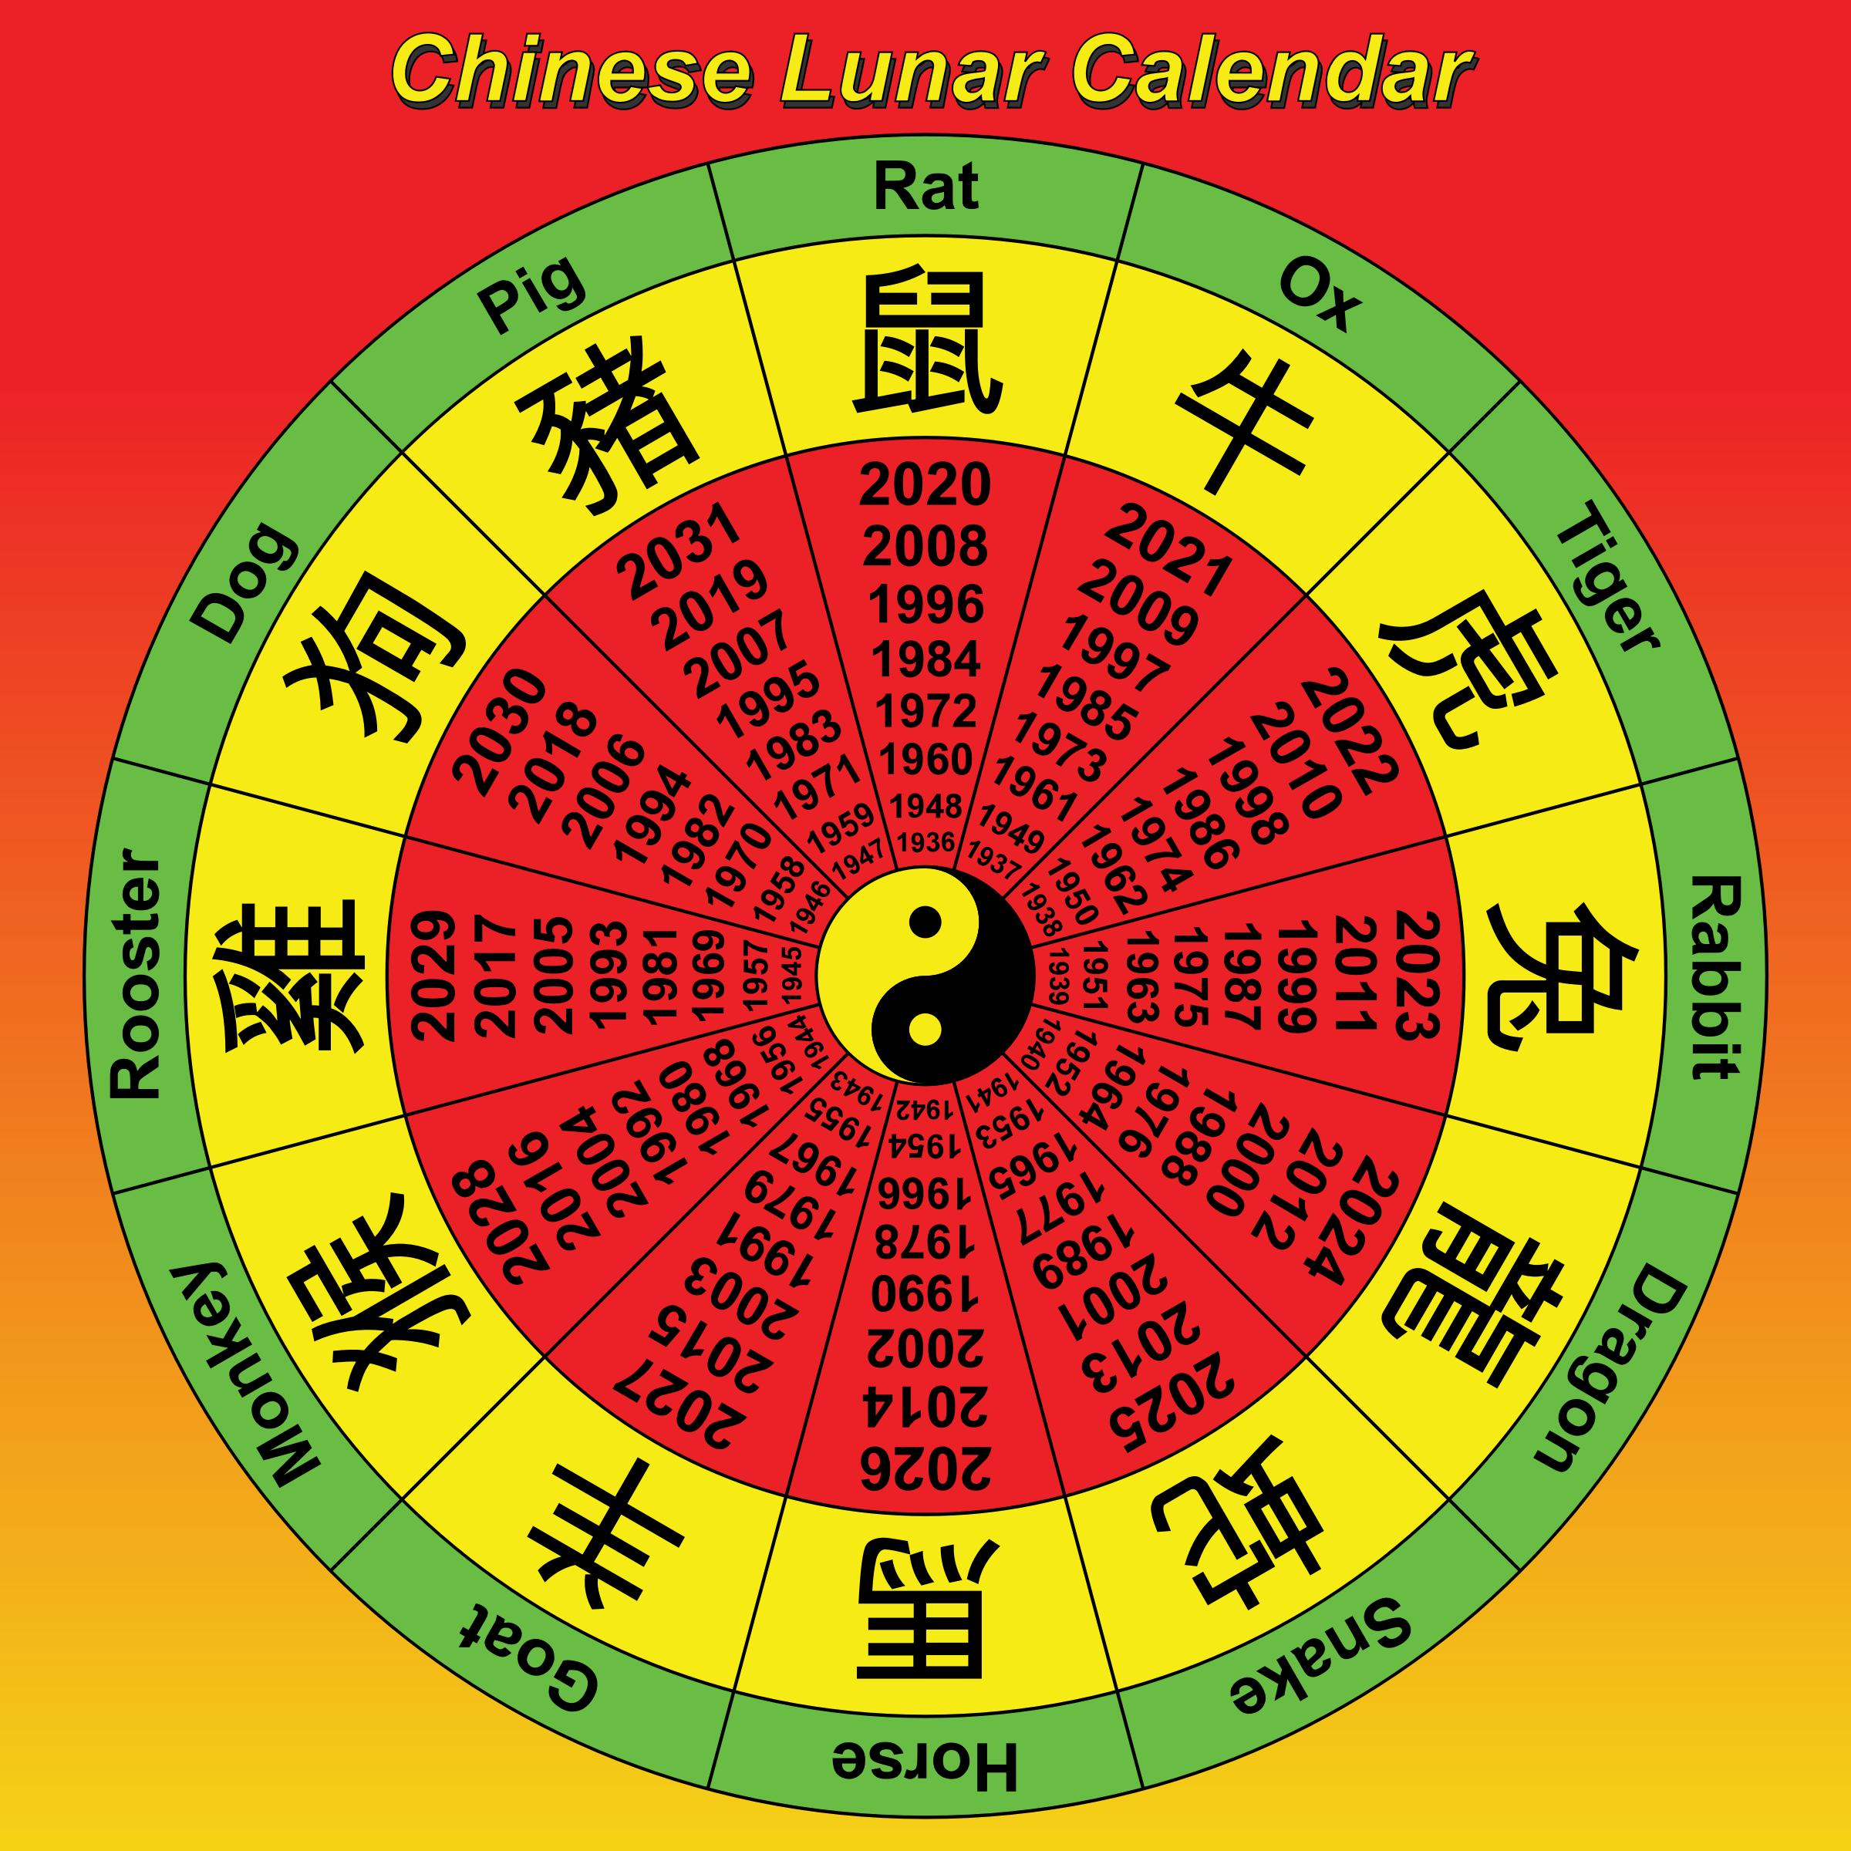
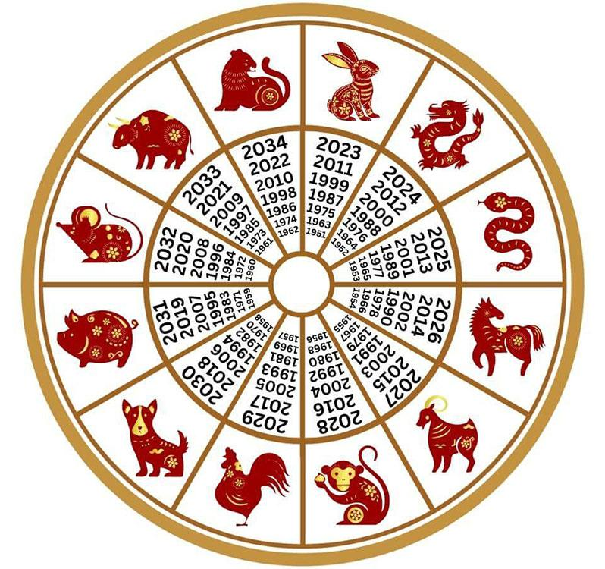

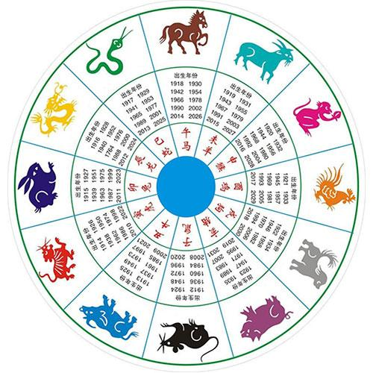
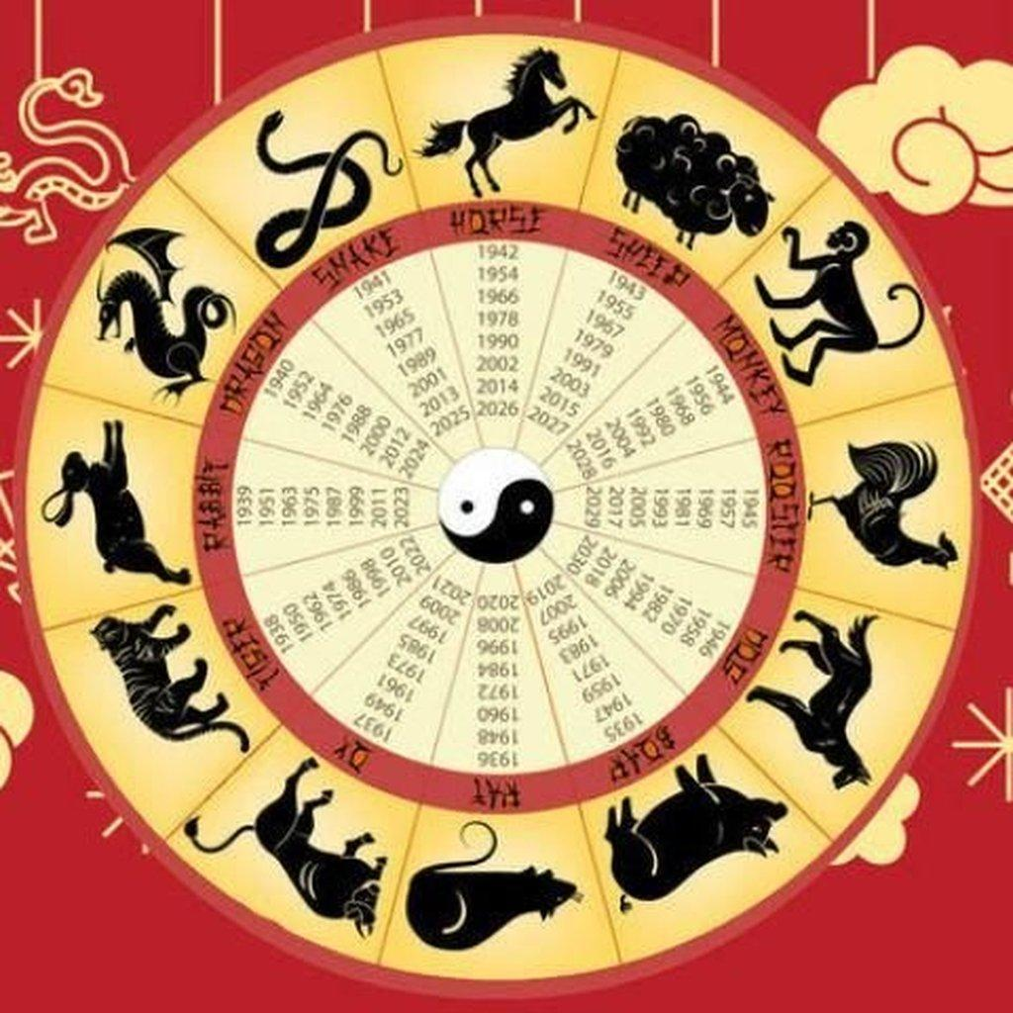
Characteristics
- 12 or 13 months
- Leap month added when necessary
- Maintains seasonal alignment
Used for:
- Chinese New Year
- Lantern Festival
- Mid-Autumn Festival
- Dragon Boat Festival

3. Traditional Hindu Calendars
# Source: AI Source: Provided by: [Data Path: Persons Table -> ID Column: 1, Name_En Column: Motasem Essam] -> From: [ChatGPT] on [7/17/2026]
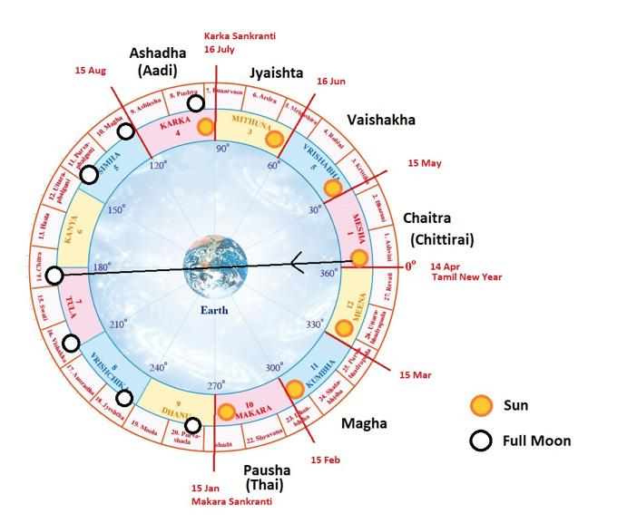
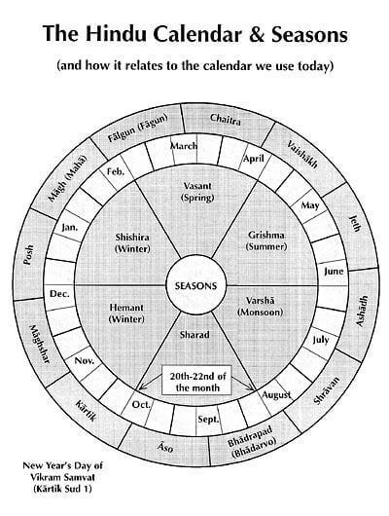
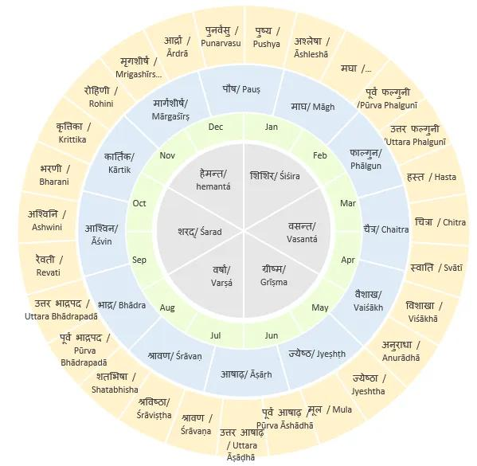
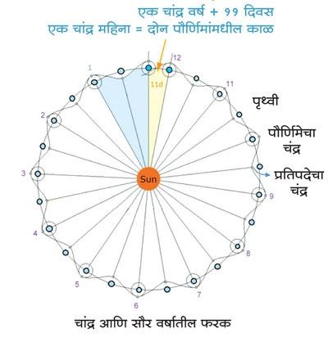
Characteristics
- Lunisolar system
- Regional variations
- Leap month (Adhik Maas) inserted periodically
Used for:
- Religious festivals
- Temple observances
- Traditional ceremonies

Length of the Year
# Source: AI Source: Provided by: [Data Path: Persons Table -> ID Column: 1, Name_En Column: Motasem Essam] -> From: [ChatGPT] on [7/17/2026]
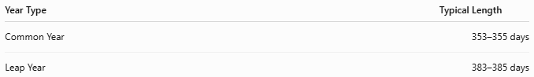
Year Type | Typical Length
Common Year | 353–355 days
Leap Year | 383–385 days

Advantages
# Source: AI Source: Provided by: [Data Path: Persons Table -> ID Column: 1, Name_En Column: Motasem Essam] -> From: [ChatGPT] on [7/17/2026]
A lunisolar calendar:
- Preserves lunar months.
- Keeps festivals in the correct seasons.
- Supports agriculture.
- Maintains traditional religious observances.
- Balances astronomical accuracy with cultural needs.

Limitations
# Source: AI Source: Provided by: [Data Path: Persons Table -> ID Column: 1, Name_En Column: Motasem Essam] -> From: [ChatGPT] on [7/17/2026]
A lunisolar calendar:
- Is more complex than purely solar or lunar calendars.
- Requires leap-month calculations.
- Has varying year lengths.
- Is less commonly used for international civil purposes.

Applications
# Source: AI Source: Provided by: [Data Path: Persons Table -> ID Column: 1, Name_En Column: Motasem Essam] -> From: [ChatGPT] on [7/17/2026]
Lunisolar calendars are used in:
- Religious observances
- Cultural celebrations
- Traditional festivals
- Agriculture
- Historical studies
- Community calendars

Comparison with Other Calendar Systems
# Source: AI Source: Provided by: [Data Path: Persons Table -> ID Column: 1, Name_En Column: Motasem Essam] -> From: [ChatGPT] on [7/17/2026]
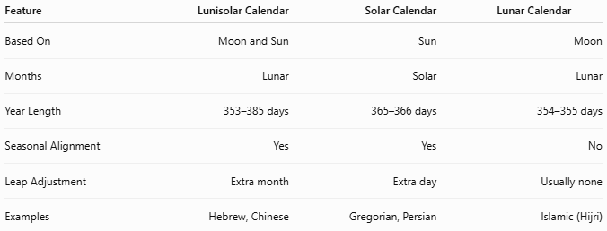
Feature | Lunisolar Calendar | Solar Calendar | Lunar Calendar
Based On | Moon and Sun | Sun | Moon
Months | Lunar | Solar | Lunar
Year Length | 353–385 days | 365–366 days | 354–355 days
Seasonal Alignment | Yes | Yes | No
Leap Adjustment | Extra month | Extra day | Usually none
Examples | Hebrew, Chinese | Gregorian, Persian | Islamic (Hijri)

Common Mistakes
# Source: AI Source: Provided by: [Data Path: Persons Table -> ID Column: 1, Name_En Column: Motasem Essam] -> From: [ChatGPT] on [7/17/2026]
- Confusing a lunisolar calendar with a lunar calendar.
- Assuming leap years always add a single day (lunisolar calendars add a month).
- Believing all lunisolar calendars use the same leap-month rules.
- Assuming festivals occur on the same Gregorian date every year.

Key Points
# Source: AI Source: Provided by: [Data Path: Persons Table -> ID Column: 1, Name_En Column: Motasem Essam] -> From: [ChatGPT] on [7/17/2026]
- A Lunisolar Calendar combines:
  - Lunar months
  - Solar seasonal alignment
- It contains:
  - 12 months in common years.
  - 13 months in leap years.
- A leap month is periodically added to keep the calendar synchronized with the seasons.
- Major examples include:
  - Hebrew Calendar
  - Chinese Calendar
  - Traditional Hindu Calendars

Conclusion
# Source: AI Source: Provided by: [Data Path: Persons Table -> ID Column: 1, Name_En Column: Motasem Essam] -> From: [ChatGPT] on [7/17/2026]
A Lunisolar Calendar combines the Moon's monthly cycle with the Sun's yearly cycle, allowing months to follow the lunar phases while keeping the calendar aligned with the seasons through the addition of leap months. This balance makes it especially well suited for cultures and religions whose festivals depend on both lunar observations and seasonal timing. Prominent examples include the Hebrew Calendar, the Chinese Calendar, and several traditional Hindu calendars, all of which continue to play important cultural and religious roles today.

